

**29 January 2021**

Dear Treasurer,

I would like to take this opportunity to wish you a very happy new year and also to introduce myself as the Director of Finance. I join the Diocese of Oxford from the Diocese of Leicester, where I held the position of Director of Finance and Support Services. I am hugely excited about joining the Diocese and a team that has been so expertly led by Alison Jestico. I look forward to connecting with you as this year unfolds.   
  
2020 was a challenging year in every place. I hope that my knowledge of diocesan and parish finance means that I can work quickly and closely with you in responding to the pandemic. There are four things to cover in this note:

1. Parish Share 2021
2. Parochial Fees 2020 and 2021
3. PCC Trusts held by ODBF & Diocesan Trustees (Oxford) Ltd
4. Treasurer Training and Accounts guidance

Before all that, **a huge thank you** to you and your colleagues for your parish share contributions in 2020. We received 94.4% of share and I know that it has taken a lot of hard work in very difficult circumstances to raise the funds. Your contribution towards clergy stipends and housing and all the mission work of the Diocese is much appreciated. You will find the total of share received in 2020 [**on the Diocesan website.**](https://anglican.us2.list-manage.com/track/click?u=14501d5eebc3e98fa3015a290&id=50c500ae19&e=85e18395eb)

**1. Parish Share 2021**  
We have received the allocations from deanery officers, and these are now available on the Diocesan website together with a [**recently revised parish share leaflet**](https://anglican.us2.list-manage.com/track/click?u=14501d5eebc3e98fa3015a290&id=706089b266&e=85e18395eb).   
  
If you have not been informed of your share by your deanery, [**you will find the information you need on the website**](https://anglican.us2.list-manage.com/track/click?u=14501d5eebc3e98fa3015a290&id=9a4b4fe8f3&e=85e18395eb). If you have any questions about your allocation, please address them to your deanery treasurer.     
  
**Parish Share Discount**  
A discount of 1% is given to any parish who arrange to pay their share in full by Direct Debit. This will be deducted from the amount of the allocation when the Direct Debit is set up by us, so that we collect 99% of share. Alternatively, if you have paid your 2021 share in full by 14 February (normally by 31 January, but we’ve extended the deadline for this year only) you will also receive the discount, in which case, please pay 99% of the allocated amount.   
  
For 2021, we will also be offering a discount to any parish who pays their share by Direct Debit but is not able to commit to contributing their full allocation at this stage. A discount of 0.5% of total contribution received by 30 June 2021 will be given to these parishes.     
  
**Payment of Share**  
I am sure you are aware that there are various ways that you can pay your parish share. I would like to encourage you to pay regularly as we, of course, pay the clergy monthly.    
  
**a. By Direct Debit** - If you wish to start to pay by Direct Debit, [**please complete this form**](https://anglican.us2.list-manage.com/track/click?u=14501d5eebc3e98fa3015a290&id=3f2474c0cc&e=85e18395eb) and email it to [**finance@oxford.anglican.org**](mailto:finance@oxford.anglican.org). We will arrange to collect your parish share contributions over the year around the 15th of each month. We will give the 1% discount for the year for those who send us the form by the start of March.    
  
If your parish has already signed up, your instruction remains in place; you do not need to complete a new one. We will shortly be sending the annual notification of amounts and collection dates to each PCC treasurer. If you do not receive this, please email [**liz.holloway@oxford.anglican.org**](mailto:liz.holloway@oxford.anglican.org).   
  
**b. By Standing Order** over ten months from February to November.  
  
**c. By cheque or bank transfer.** Please make your cheque payable to Oxford Diocesan Board of Finance and send it to ODBF Finance Department, Church House Oxford, Langford Locks, Kidlington OX5 1GF.   
  
If you would prefer to use a bank transfer, the details are as follows:-   
Bank: NatWest   
Account name: Oxford Diocesan Board of Finance   
Sort code: 60-03-57   
Account number: 78802938   
  
**d. By transfer from your CBF account** to the ODBF Parish Share account 127001446D.     
  
**Note:** It is important that you quote your **parish share reference number and parish name** so that we can identify your payment. Please note that for 2021, these are the same as last year and start with the letter “S”. If you need to find your reference number, [**please visit the website**](https://anglican.us2.list-manage.com/track/click?u=14501d5eebc3e98fa3015a290&id=ef6c33d6c5&e=85e18395eb) and look for your parish within the share statements.     
  
Thank you, in advance, for the contribution your PCC will make towards ministry and mission in your parish and the work of the Diocese in 2021.    
  
  
**2. Parochial Fees 2020 and 2021**  
Many thanks to those who have submitted parochial fee returns for weddings and funerals to date. Please do continue to send these in quarterly. Please can we remind you to send in the Q4 parochial fee return for 2020 before the end of January. Once again, it is important to quote your **reference number, parish and benefice** and to use the correct form for each year. Please also send just one payment with each quarterly return.  
  
[**Our Diocesan Parochial Fees webpage**](https://anglican.us2.list-manage.com/track/click?u=14501d5eebc3e98fa3015a290&id=8b8159b719&e=85e18395eb) has all the correct forms and necessary information.  
  
  
**3. PCC Trusts held by ODBF & Diocesan Trustees (Oxford) Ltd**  
Due to current restrictions and works being done at Church House, the office is closed and we are all working from home for the next couple of months. This means there is likely to be a delay in sending out the annual Trust statements. We know parishes will be anxious to complete their accounts ready for auditing. We would kindly ask you to please bear with us, and we will strive to get these sent as soon as we are able.   
  
   
**4. Treasurer Training and Accounts guidance**  
I am sure many of you will be beginning to think about the financial year-end of 31 December and producing your Annual Report and Accounts. [**Guidance on producing PCC Accounts is available here.**](https://anglican.us2.list-manage.com/track/click?u=14501d5eebc3e98fa3015a290&id=f034c22a71&e=85e18395eb)  
  
In particular, we would like to draw your attention to the structure of the annual report and accounts, as sometimes we only receive partial versions – as you will see in the Parish Resources guidance, the full document should have four elements:

* The Trustees Annual Report
* The Receipts and Payments Account/SOFA
* The Statement of Assets and Liabilities
* The Independent Examiners Report

We have a one-page summary of an [**annual church financial calendar here.**](https://anglican.us2.list-manage.com/track/click?u=14501d5eebc3e98fa3015a290&id=40590ccc90&e=85e18395eb)  
  
We have received queries regarding whether independent examinations or (if required) audits of PCC accounts should take place in the current circumstances. These should only take place where it is safe to do so and complies with all current restrictions. It may be necessary to delay such work until the current restrictions are lifted. Everyone’s safety is of paramount importance.    
  
In a communication to PCC secretaries and incumbents, we are suggesting PCCs may not want to schedule APCMs for earlier than the middle of April. Of course, if serious restrictions continue, thought will have to be given to whether an extension is required, but we are currently hopeful we can keep to a normal timetable. A full APCM pack will be available in early February.   
  
I would be very happy to provide some treasurer training in the next few weeks but would like to assess the demand for such an online event. Normally topics would include how to prepare year-end accounts and fund accounting. If you would like to attend such an event (and have a PCC finance-related topic you would like to be covered), can you please send an email to [**finance@oxford.anglican.org.**](mailto:finance@oxford.anglican.org)   
  
Finally, the finance team at Church House would like to thank you all, sincerely, for your hard work throughout 2020 in supporting your parish and in assisting us here at Church House.   
  
Yours sincerely,    
  
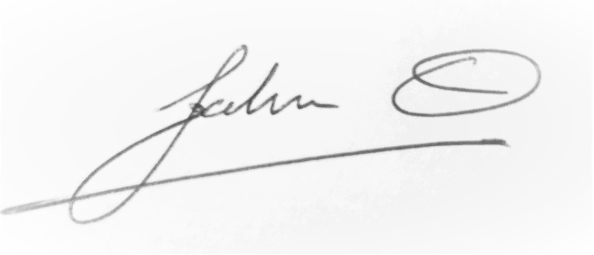  
  
**John Orridge  
Director of Finance**