THE MINISTRY of THAME

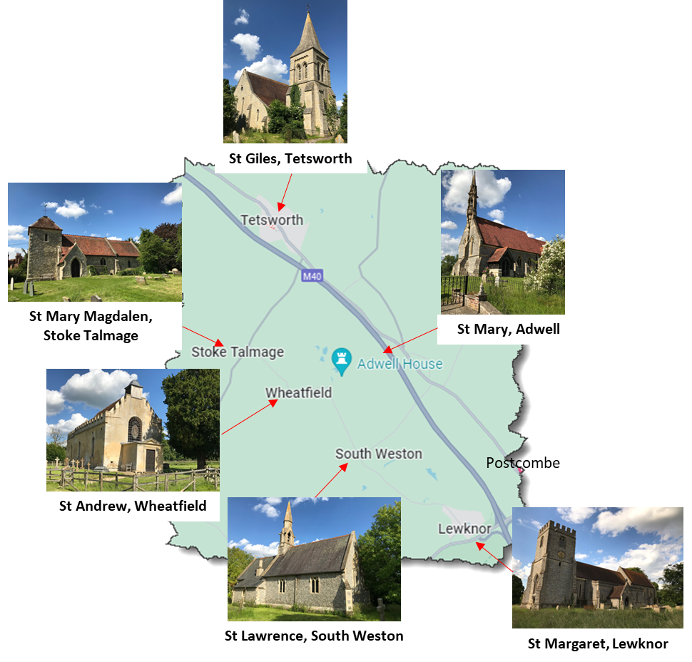
Tetsworth Benefice
A BRIEF DESCRIPTION OF THE RURAL TETSWORTH BENEFICE
WELCOME!
Welcome to the Benefice of Tetsworth!
In this short document we hope to describe our benefice, who we are, how we organise ourselves, what makes us tick, and what we hope for.
The Benefice of Tetsworth is a community of people who strive to work as one to further the work of the church in our small parishes.

WHAT IS THE TETSWORTH BENEFICE?
The Benefice is a small community of just 1,500 souls, spread across 6 small villages.
The Benefice was created in 1981 as part of, and with the support of, the Thame Team Ministry. Since 2010 we have operated very successfully with a House for Duty vicar living in our Rectory in Tetsworth, tending to the needs of our community.

BENEFICE ORGANISATION
Over the years we have streamlined the organisation of the Benefice to ensure that our vicar is not burdened with the administration of 6 parishes.
The Tetsworth Benefice Council is responsible for the following:
- All parish returns to the diocese
- Payment of Fees
- Payment of Parish shares
- Organisation of Service Rota

PARISH ORGANISATION
Each Parish is responsible for:
- Collection of Parish Share
- Cleaning and maintenance of the Church and the Churchyard
- Preparation of the Church for services
- Organisation of lay led services or visiting priests
- Safeguarding and health and safety
If any major restoration project is necessary, this is organised by the parish responsible.

RESPONSIBILITIES OF OUR HOUSE FOR DUTY VICAR
We see our HfD as being responsible for:
- Being a shepherd to the 1,500 souls within our parishes
- Conducting Sunday services and other special offices
- Praying for us

CHURCH SERVICES
There are 6 Churches within the benefice and the Benefice Council has agreed that there should be one HfD led service in each church per month.
Thus our HfD must conduct a minimum of 72 services per year, plus occasional offices not falling on Sundays. In a normal month, therefore, there will be 6 HfD services, with the HfD presiding at one service on 2 of the Sundays and 2 services on the other 2 Sundays.
Some churches may wish to have more than one service per month in which case the churchwardens of those churches will organise lay led services or services conducted by visiting priests.

WHAT ARE WE PRAYING FOR?
We want to welcome into our Benefice someone who will:
- Embrace and become part of a close community of straightforward people who want our Churches to support those who live and work in our villages
- Focus on the pastoral work necessary to make the Church the centre of our community
- Allow the Tetsworth Benefice Council to continue taking responsibility for administrative and financial tasks
- Embrace the support which the Thame Benefice can and will provide where required.

WHAT WE CAN OFFER
We can offer a recently refurbished 4-bedroom house in the village of Tetsworth, within 12 miles of Oxford and 40 miles of London.
We can cover basic clergy expenses
We will provide support and enthusiasm
We insist upon friendship and laughter

